# Business Requirements Document (BRD)

## Feature Name: Enhanced Filtering for RFP and Proposal List UI

## 1. Objective

The objective is to enhance the usability and efficiency of the RFP and Proposal List UIs by implementing checkbox-based filters. These filters will allow users to focus exclusively on the RFPs and proposals relevant to their responsibilities, reducing data clutter, streamlining workflows, and delivering a more intuitive and professional user experience.

## 2. Problem Statement

The RFP and Proposal List UIs currently display all RFPs and proposals across the system, presenting users with an overwhelming amount of data to process. This broad view requires users to manually search through extensive lists to identify the RFPs and proposals they are actively involved with. Users need a more focused view that:

* - Highlights the RFPs they are directly responsible for.
* - Shows only proposals associated with those RFPs.

Without targeted filtering options, the system creates inefficiencies, increases the risk of oversight, and leads to frustration, particularly for users managing large volumes of RFPs and proposals.

## 3. Proposed Solution

Introduce a checkbox-based filtering mechanism for both the RFP and Proposal List UIs:

### For RFPs:

- Add a checkbox labeled 'Show My RFPs Only'.  
- When Checked: Display only RFPs where the logged-in user is either:  
 - The Creator, or  
 - The Last Modifier.  
- When Unchecked: Display all RFPs in the system.

### For Proposals:

- Add a checkbox labeled 'Show Proposals for My RFPs Only'.  
- When Checked: Display only proposals linked to RFPs where the logged-in user is either:  
 - The Creator, or  
 - The Last Modifier of the associated RFP.  
- When Unchecked: Display all proposals in the system.

### New Group Rule for Default Behavior:

Introduce a new group rule to determine whether the checkbox is checked or unchecked by default for each group:  
- Groups can be configured to have the checkbox:  
 - Checked by default: Relevant records only.  
 - Unchecked by default: Display all records.

### Search Filter Persistence:

Save the checkbox state along with other search filters in the user's session to ensure consistency across navigation and page reloads.

### UI Placement:

Place the checkboxes prominently at the top of the existing search filter section in both the RFP and Proposal List UIs for easy access.

### Performance Considerations:

Implement server-side filtering to handle large datasets efficiently and ensure quick load times for filtered and unfiltered views.

## 4. Scope

### In-Scope:

- Adding checkbox filters:  
 - 'Show My RFPs Only' for the RFP List UI.  
 - 'Show Proposals for My RFPs Only' for the Proposal List UI.  
- Default checkbox behavior based on group rules.  
- Persistence of checkbox state across user sessions.  
- Server-side filtering to ensure efficient data loading and improved performance.

### Out of Scope:

- Changes to existing filtering options for RFPs and proposals.  
- Modifications to the database schema or additional data fields.  
- Error handling for missing or incorrect RFP-Proposal links, as proposals cannot exist without a linked RFP.

## 5. Functional Requirements

### Checkbox Functionality:

For RFP List UI:  
- Checkbox: 'Show My RFPs Only'.  
 - Default State: Determined by group rules.  
 - Filter Criteria: Include RFPs where the logged-in user is the Creator or the Last Modifier.  
 - Display all RFPs when unchecked.

For Proposal List UI:  
- Checkbox: 'Show Proposals for My RFPs Only'.  
 - Default State: Determined by group rules.  
 - Filter Criteria: Include proposals linked to RFPs where the user is the Creator or the Last Modifier of the linked RFP.  
 - Display all proposals when unchecked.

### Default Behavior and Overrides:

Group rules will define whether the checkbox is checked or unchecked by default for each user group. User preferences (set during a session) will override the default group behavior in subsequent sessions.

### Persistence of Filter State:

Store the checkbox state in the user session alongside other search filters. Ensure that the state persists across page reloads and navigation until explicitly changed by the user.

### Performance Optimization:

Implement server-side filtering to handle large datasets efficiently and ensure filtered data loads within acceptable time limits.

## 6. Non-Functional Requirements

1. Performance: Filtered data should load within 2 seconds for the majority of users.  
2. Scalability: The filtering mechanism must support systems with a high volume of RFPs and proposals without performance degradation.  
3. Usability: The checkbox placement and labeling must be intuitive for users.  
4. Reliability: Filters must work consistently without exceptions or errors.

## 7. Risks

### Reduced Data Visibility:

Users may unintentionally leave the checkbox checked and miss relevant RFPs or proposals.  
Mitigation:  
- Ensure the checkbox is prominently visible.  
- Allow users to uncheck the box to display all data.

### Misalignment of Default Rules:

Group-defined defaults may not align with individual user expectations.  
Mitigation:  
- Allow user preferences to override group rules after the first use.

## 8. UI/UX Changes

**RFP List UI**:  
  
- Add a checkbox labeled 'Show My RFPs Only' at the top of the search filters.

Default state of this check will be determine by the group Rule.

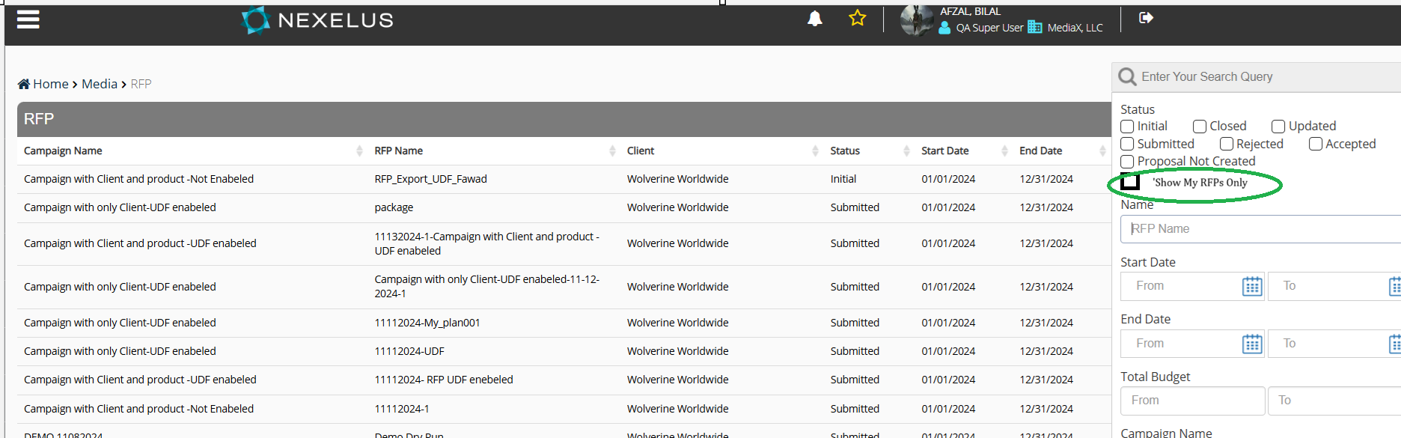

**Suggestion:** Apart from this check box, system should not display “Closed” RFPs by default.

**Proposal List UI:**  
  
  
  
- Add a checkbox labeled 'Show Proposals for My RFPs Only' at the top of the search filters.

- Default state of this checkbox will be determined by the Group Rule

**Suggestion**: We shouldn’t show “Approved” and “Rejected” proposals by default.

## 9. Assumptions

1. All proposals are linked to a single RFP, and this relationship is accurately stored in the database.  
2. Existing filtering options for RFPs and proposals are functional and remain unchanged.  
3. Users have appropriate permissions to view relevant RFPs and proposals.

## 10. Success Criteria

1. Users can easily filter RFPs and proposals using the new checkboxes.  
2. The system respects group rules for default behavior and user preferences for subsequent sessions.  
3. Filtered data loads within acceptable performance thresholds, even for large datasets.  
4. Users report increased satisfaction with the list UIs due to improved focus and efficiency.